2020BTECS00023

Batch – T5

Software Engineering Tools Lab

Assignment No. 1

1. Differentiate in between free software, Open source software and proprietary software with respect to its properties.

Free Software: “Free software” means software that respects users’ freedom and community. Roughly, it means that the users have the freedom to run, copy, distribute, study, change and improve the software. The term “free software” is sometimes misunderstood—it has nothing to do with price. It is about freedom.

Open Source Software: Open Source Software is something that you can modify as per your needs, and share with others without any licensing violation burden. When we say Open Source, the source code of the software is available publicly with Open Source licenses like GNU (GPL) which allows you to edit the source code and distribute it. Read these licenses and you will realize that these licenses are created to help us.

Coined by the development environments around software produced by open collaboration of software developers on the internet.

Later specified by the Open Source Initiative (OSI).

It does not explicitly state ethical values, besides those directly associated with software development.

1. Open source Software: Open source software is computer software whose source code is available openly on the internet and programmers can modify it to add new features and capabilities without any cost. Here the software is developed and tested through open collaboration. This software is managed by an open-source community of developers. It provides community support, as well as commercial support, which is available for maintenance. We can get it for free of cost. This software also sometimes comes with a license and sometimes does not. This license provides some rights to users.

The software can be used for any purpose

Allows to study how the software works

Freedom to modify and improve the program

No restrictions on redistribution

Some examples of Open source software include Android, Ubuntu, Firefox, Open Office, etc.

2. Proprietary Software: Proprietary software is computer software where the source codes are publicly not available only the company that has created them can modify it. Here the software is developed and tested by the individual or organization by which it is owned not by the public. This software is managed by a closed team of individuals or groups that developed it. We have to pay to get this software and its commercial support is available for maintenance. The company gives a valid and authenticated license to the users to use this software. But this license puts some restrictions on users also like.

Number of installations of this software into computers

Restrictions on sharing of software illegally

Time period up to which software will operate

Number of features allowed to use

Some examples of Proprietary software include Windows, macOS, Internet Explorer, Google Earth, Microsoft Office, etc.

**Difference between Open-source Software and Proprietary Software:**

| S.No. | OPEN-SOURCE SOFTWARE | PROPRIETARY SOFTWARE |
| --- | --- | --- |
| 01. | Open-source software is computer software whose source code is available openly on the internet and programmers can modify it to add new features and capabilities without any cost. | Proprietary software is computer software where the source codes are publicly not available only the company which has created can modify it. |
| 02. | Here the software is developed and tested through open collaboration. | Here the software is developed and tested by the individual or organization by which it is owned not by the public. |
| 03. | In open-source software the source code is public. | In proprietary software, the source code is protected. |
| 04. | Open-source software can be installed on any computer. | Proprietary software can not be installed into any computer without a valid license. |
| 05. | Users do not need to have any authenticated license to use this software. | Users need to have a valid and authenticated license to use this software. |
| 06. | Open-source software is managed by an open-source community of developers. | Proprietary software is managed by a closed team of individuals or groups that developed it. |
| 07. | It is more flexible and provides more freedom which encourages innovation. | It is not much flexible so there is a very limited innovation scope with the restrictions. |
| 08. | Users can get open software free of charge. | Users must have to pay to get the proprietary software. |
| 09. | In open-source software faster fixes of bugs and better security are availed due to the community. | In proprietary software, the vendor is completely responsible for fixing malfunctions. |
| 10. | Limited Intellectual Property Protections | Full Intellectual Property Protections |
| 11. | Usually Developed and Maintained by non-profit organizations. | Usually Developed and Maintained by for-profit entities. |
| 12. | Examples are Android, Linux, Firefox, Open Office, GIMP, VLC Media player, etc. | Examples are Windows, macOS, Internet Explorer, Google Earth, Microsoft Office, Adobe Flash Player, Skype, etc. |

**Difference between Free Software and Open Source Software:**

| S.No. | FS Philosophy | OSS Philosophy |
| --- | --- | --- |
| 1. | It was coined by the Free Software Foundation in the 1980s. | In response to the restrictions of free software, the phrase “open source” was coined in the late 1990s. |
| 2. | Software is an important part of people’s lives. | Software is just software. There are no ethics associated directly with it. |
| 3. | Software freedom translates to social freedom. | Ethics are to be associated with the people not with the software. |
| 4. | Freedom is a value that is more important than any economical advantage. | Freedom is not an absolute concept. Freedom should be allowed, not imposed. |
| 5. | Every free software is open source. | Every open-source software is not free software. |
| 6. | There is no such issue that exists in free software. | There are many different open-source software licenses, and some of them are quite restricted, resulting in open-source software that is not free. |
| 7. | No restrictions are imposed on free software. | Open-source software occasionally imposes some constraints on users. |
| 8. | Examples: The Free Software Directory maintains a large database of free software packages. Some of the best-known examples include the Linux kernel, the BSD and Linux operating systems, the GNU Compiler Collection and C library; the MySQL relational database; the Apache web server; and the Sendmail mail transport agent. | Examples: Prime examples of open-source products are the Apache HTTP Server, the e-commerce platform Open Source Commerce, internet browsers Mozilla Firefox, and Chromium (the project where the vast majority of development of the freeware Google Chrome is done), and the full office suite LibreOffice. |

2. Enlist some examples along with its purpose and properties (at least 10) of FOSS and

proprietary software with respect to database.

3. Enlist some examples of free open source exam software for online assessment.

**11 Free Open Source Exam Software List for Online Assessment**

* [TCExam](https://www.techjockey.com/blog/7-free-open-source-exam-software#tcexam)
* [VirtualX](https://www.techjockey.com/blog/7-free-open-source-exam-software#virtualx)
* [Moodle](https://www.techjockey.com/blog/7-free-open-source-exam-software#moodle)
* [TAO](https://www.techjockey.com/blog/7-free-open-source-exam-software#tao)
* [Kaldin](https://www.techjockey.com/blog/7-free-open-source-exam-software#Kaldin)
* [Papershala](https://www.techjockey.com/blog/7-free-open-source-exam-software#papershala)
* [Edbase](https://www.techjockey.com/blog/7-free-open-source-exam-software#edbase)
* [Mettl](https://www.techjockey.com/blog/7-free-open-source-exam-software#mettl)
* [FlexiQuiz](https://www.techjockey.com/blog/7-free-open-source-exam-software#flexiquiz)
* [Eklavvya](https://www.techjockey.com/blog/7-free-open-source-exam-software#eklavya)
* [Think Exam](https://www.techjockey.com/blog/7-free-open-source-exam-software#think_exam)

4. Demonstrate any one exam software which is open source and freely available.

* [VirtualX](https://www.techjockey.com/blog/7-free-open-source-exam-software#virtualx)

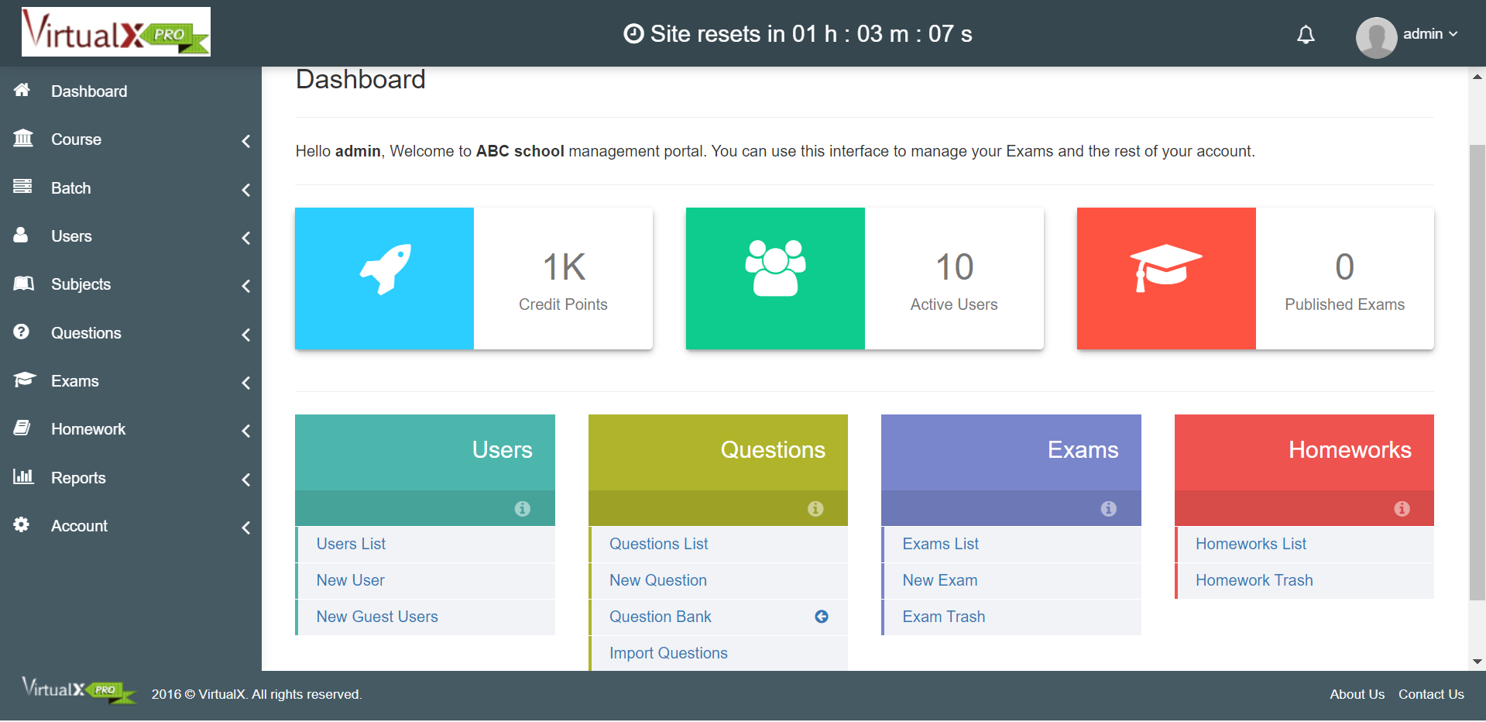

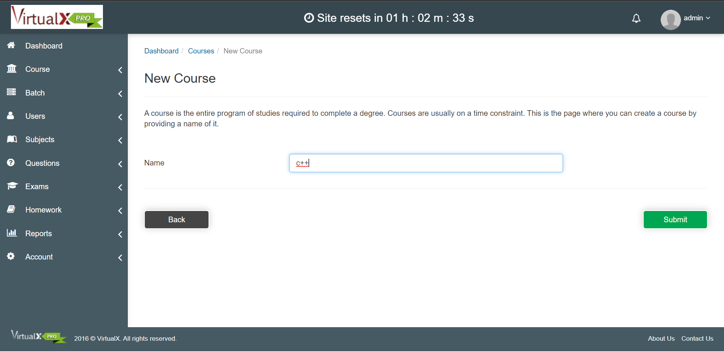

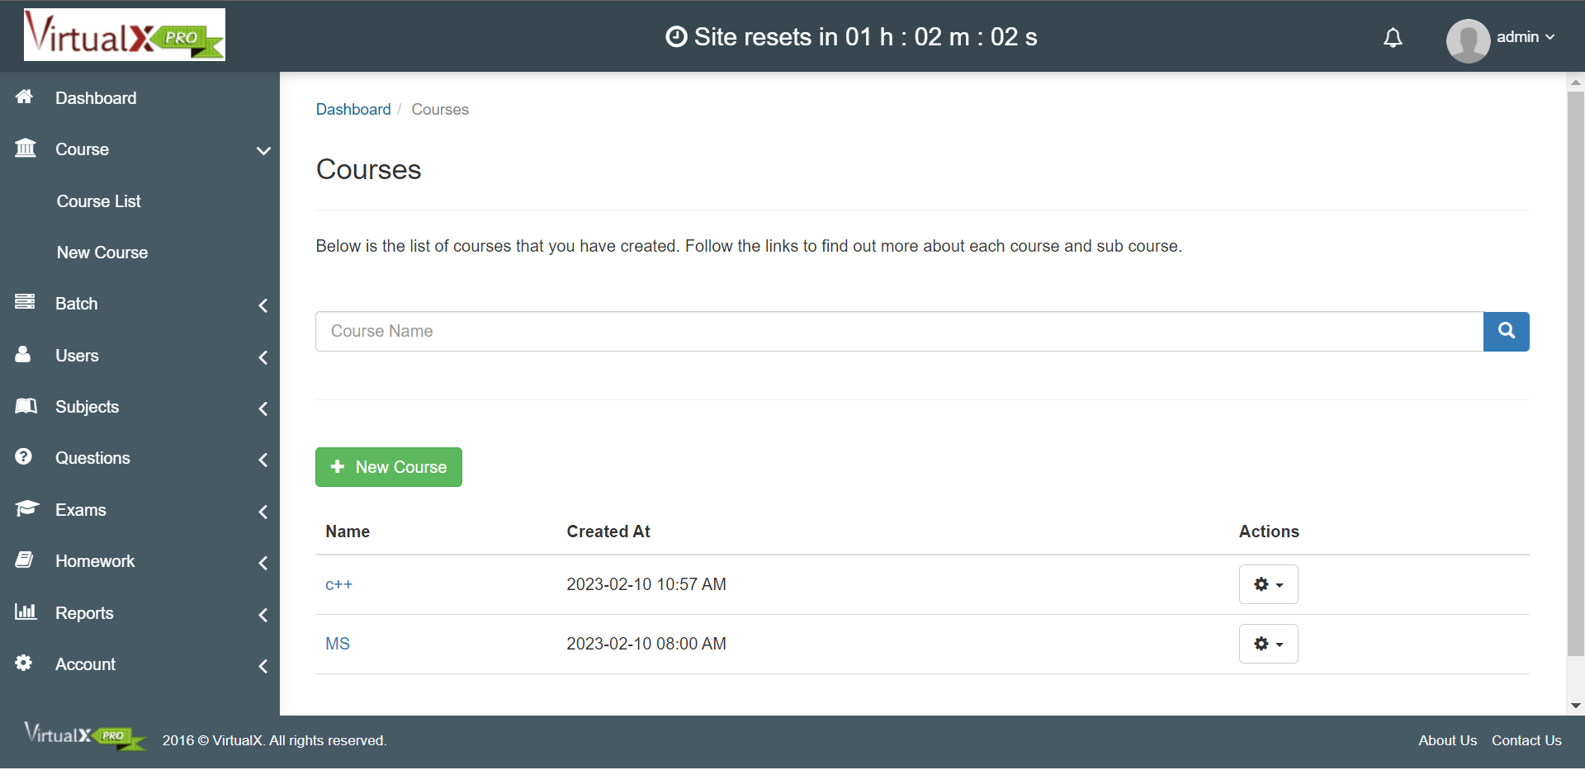

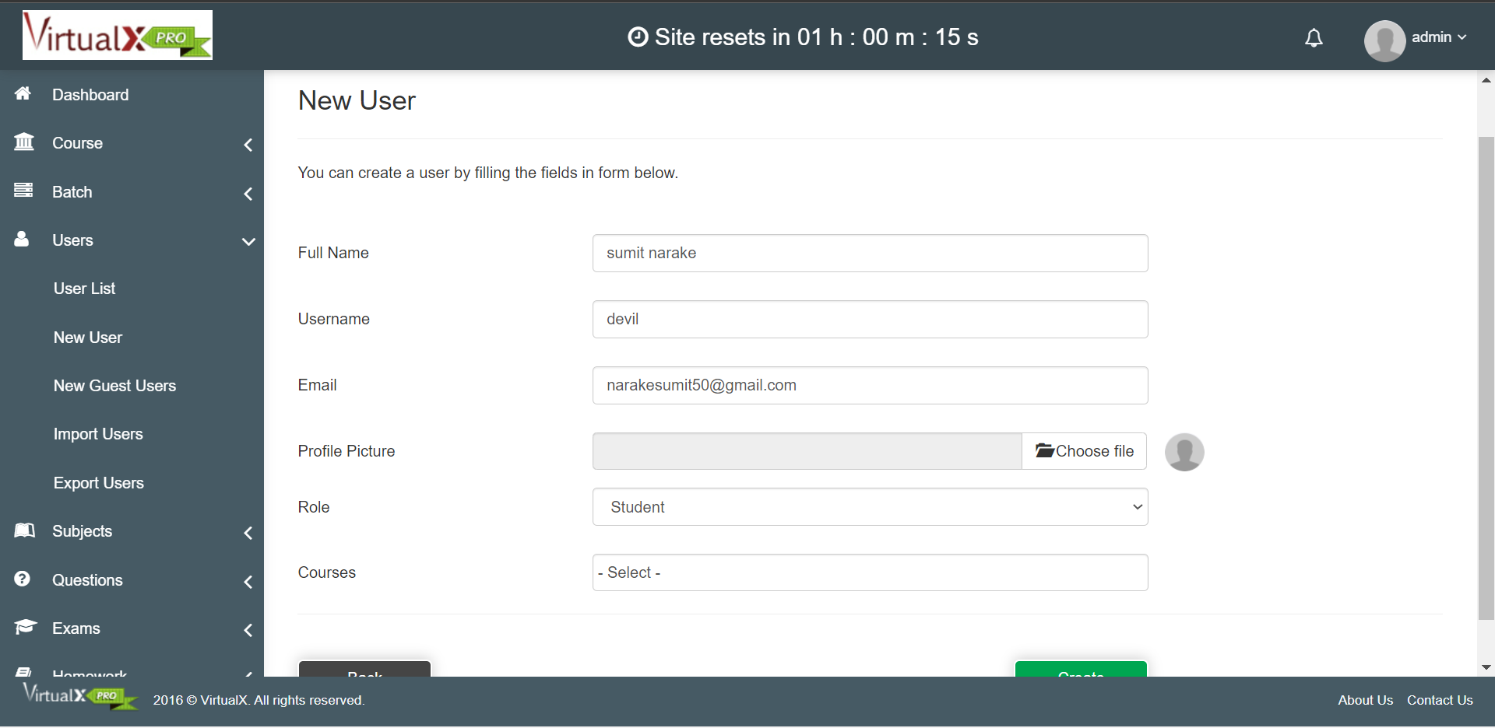

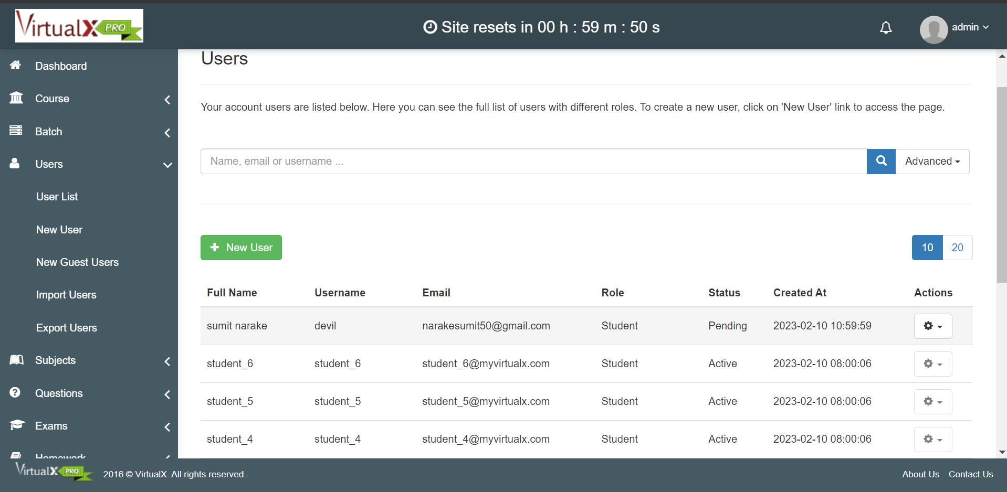

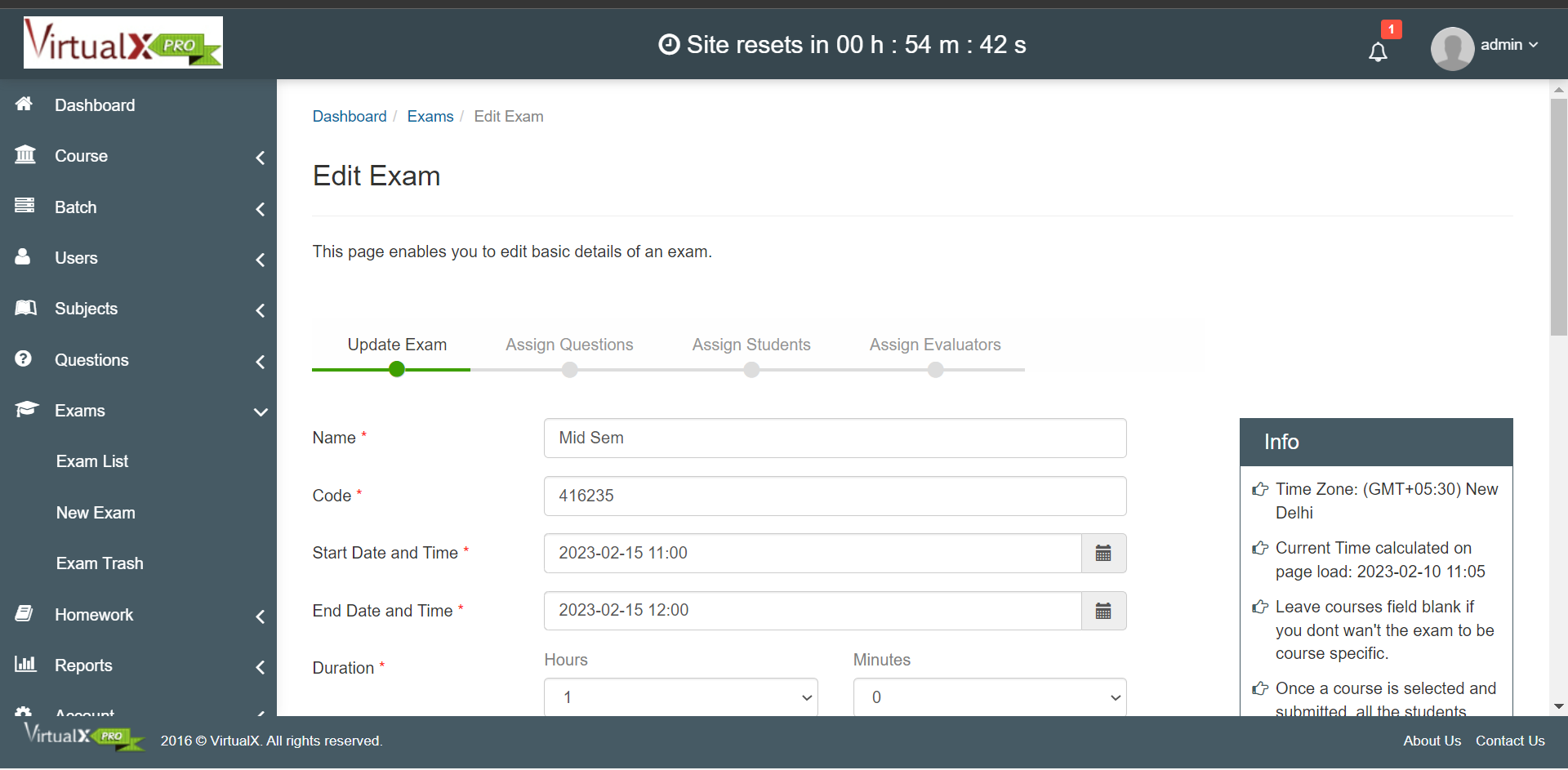

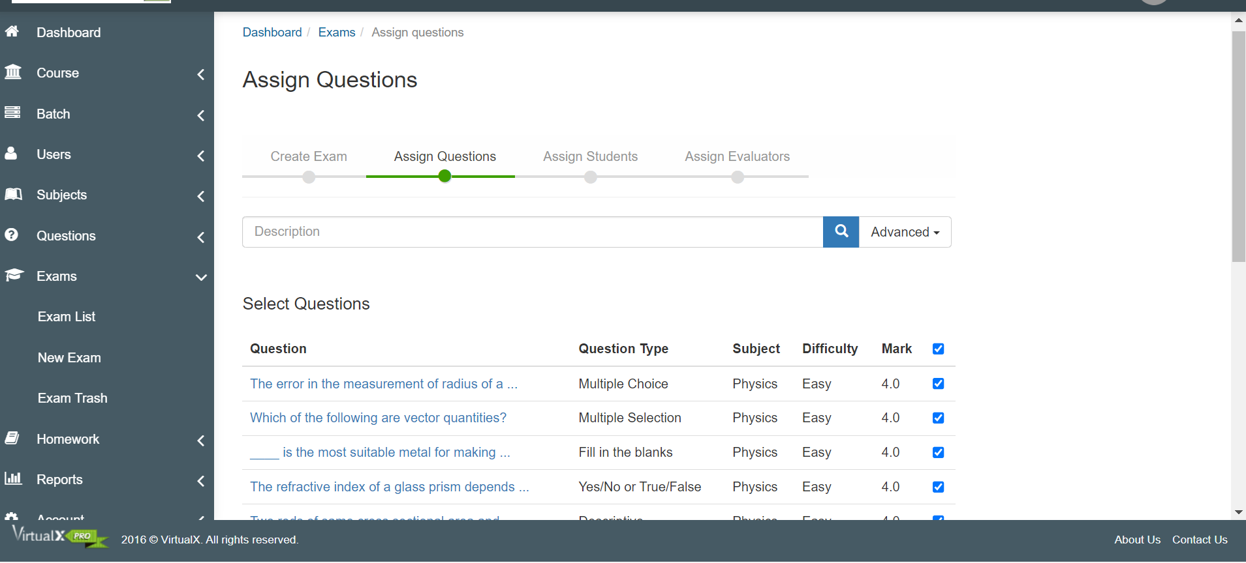

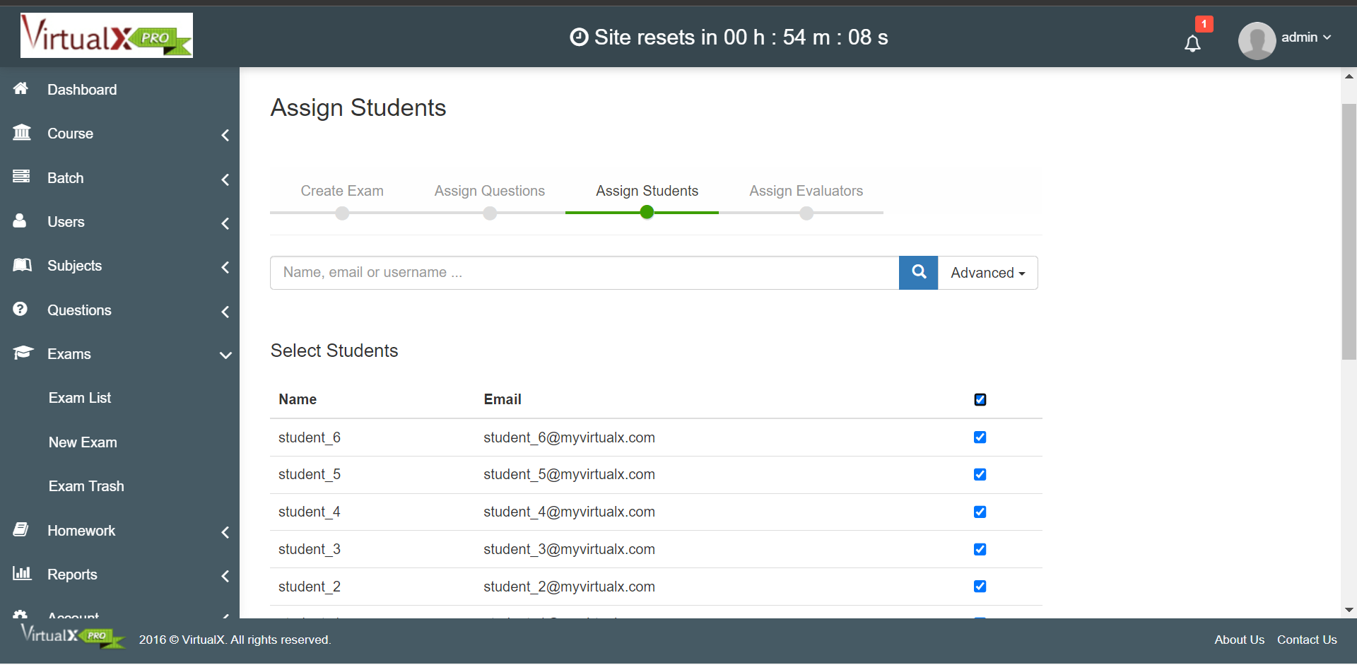

5. Demonstrate FOSS software related to database.

An open source database is any database application with a codebase that is free to view, download, modify, distribute, and reuse. Open source licenses give developers the freedom to build new applications using existing database technologies.

Open source database management systems provide a layer of abstraction developers can use to store information for organizations and their applications.

Databases are typically categorized into two groups:

* Relational databases: The traditional data storage approach in which key-value pairs are used to store structured data into tables consisting of columns and rows.
* NoSQL (non-relational) databases: Data stored using alternative data storage architectures, including document data store, column-oriented database, key-value store, and graph databases. Non-relational databases are the preferred choice for handling unstructured data.

Database management systems give you the software layer you need to control and manage your data for a multitude of purposes. For example, you can store business intelligence in a relational database for fast SQL queries or save unstructured image files in a graph database for an AI-powered analytics app.

**Closed source vs. open source databases**

Closed source databases are proprietary software. The source code cannot be accessed, modified, distributed, or reused. You may have to pay a subscription or licensing fees to use the database within your applications. The company that wrote the code maintains the codebase. That means you’ll have to wait for the company to add new features or address any bugs in the database management system.

In contrast, anyone can view and access the source code for open source databases. There are no licensing fees so the total cost of ownership (TCO) is lower for open source databases than for commercial databases. You can download and modify source code to power your apps free of charge and without vendor lock-in. On the flip side, though, you’re responsible for maintaining and securing your implementation of the open source database.

**Examples of open source databases**

Whether your goal is to store structured data for SQL queries or unstructured data via JSON objects, there are plenty of open source database solutions to choose from on the web.

Examples of commonly used open source relational databases include:

* MySQL

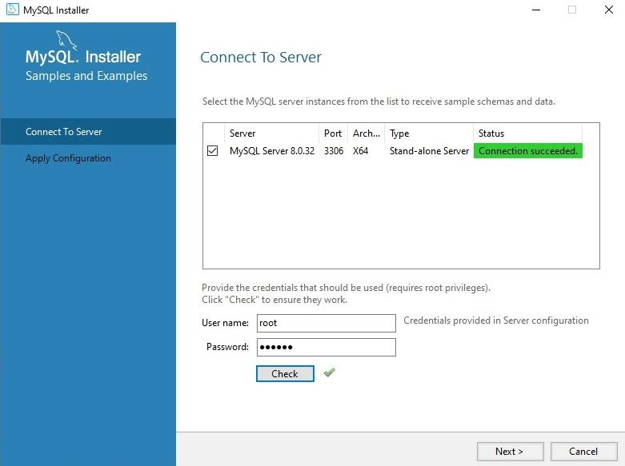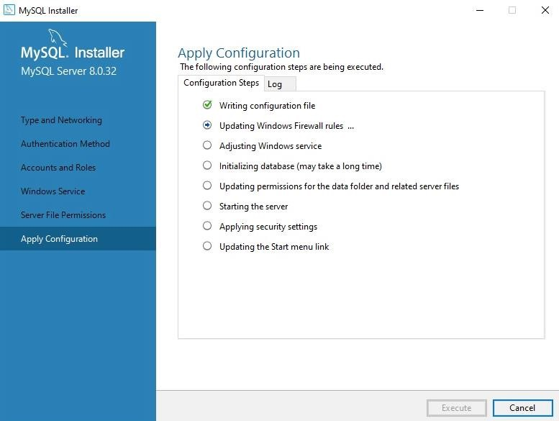

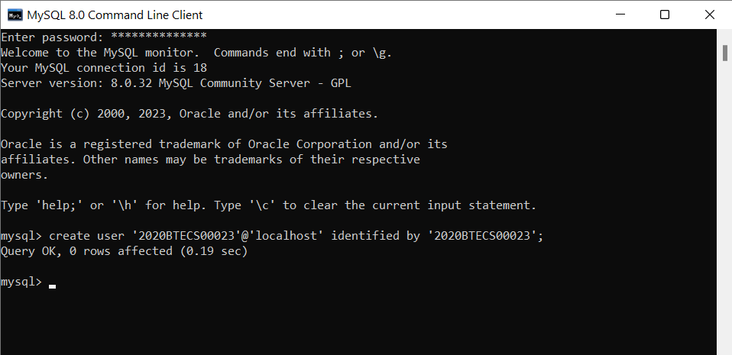

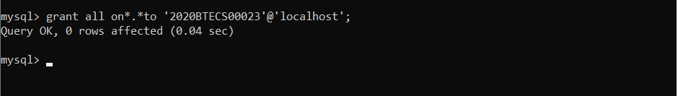

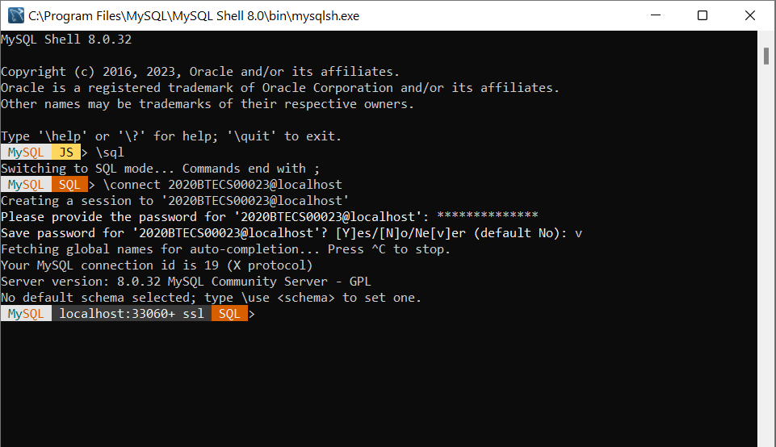

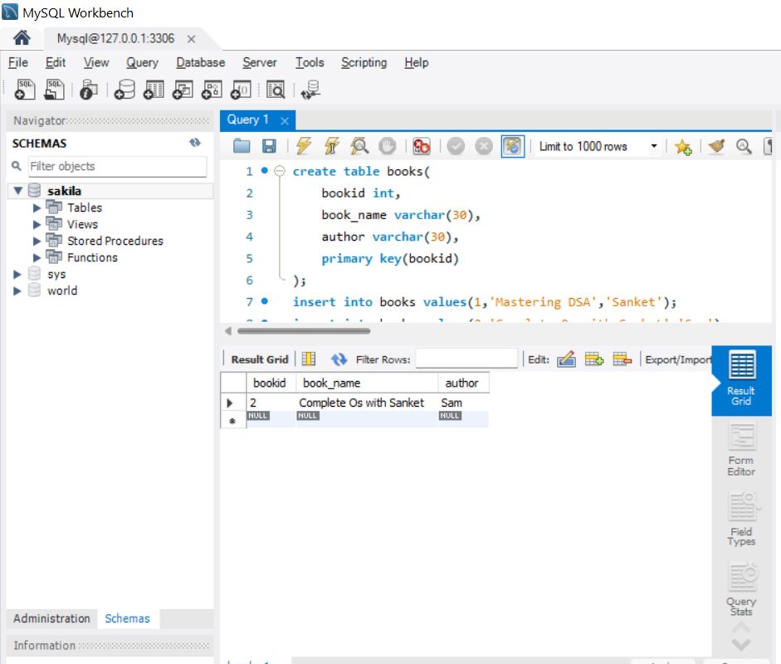

* PostgreSQL
* MariaDB

Examples of commonly used open source NoSQL databases include:

* MongoDB
* CouchDB
* Cassandra

**How to choose the right open source database for your needs**

There are several ways to choose the right database for your needs. You can analyze documentation or contact the company if documentation isn’t available publicly yet. You can also use online forums and blogs as well as the source code to help you determine which open source database may be a good fit for you.

To meet the objectives of database management, organisations need to:

* Optimise data warehouses
* Leverage cloud (distributed) computing
* Include graph databases
* Consider multidimensional database management systems (MDBMS)
* Provide AI frameworks
* Augment data management

Figure 1 lists the best free and open source database management systems and their type.

|  |  |  |
| --- | --- | --- |
| **S. No.** | **Database Name** | **Type** |
| 1 | PostgreSQL | Object-Relational Database Management System |
| 2 | MariaDB | Relational Database Management System |
| 3 | CockroachDB | Relational Database Management System |
| 4 | Neo4j | Graph Database Management System |
| 5 | CoughDB | NoSQL Database Management System |
| 6 | RethinkDB | Distributed Document-oriented Database Management |
| 7 | Redis | NoSQL Database Management System |
| 8 | SQLite | Relational Database Management System |
| 9 | Cassandra | NoSQL Database Management System |
| 10 | Timescale | NoSQL Database Management System |

Comparison :

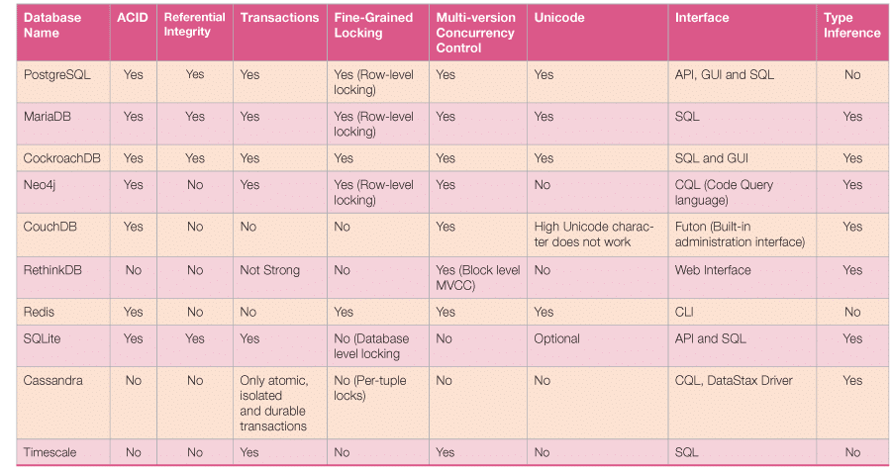

6. How does the Exam software work?

## **What are Online Proctored Exams?**

In case you don’t know, proctored exams are timed exams that you take while proctoring software monitors your computer’s desktop along with webcam video and audio. The data recorded by the proctoring software is transferred to a proctoring service for review. Proctored exams may or may not be required for your course and enrolment track.

So essentially, an online proctored exam is like any other exam but with an online infrastructure to support all the associated activities. And most importantly, invigilation, in order to maintain the sanctity of the exam room.

## **Online Proctored Exam Software: How do they work?**

Now that we know what exactly online proctored exams mean, let’s see how it works.

If you read the headline, you will notice the word “software”. A reliable, robust, and dynamic software is at the heart of any online proctoring.

Usually, the whole infrastructure is driven by a cloud-based system. Although some old organizations still rely on age-old legacy systems, it’s almost unimaginable to see how online proctoring will work without a cloud-based system given the rise of e-learning across the globe.

### Authentication of the Candidate

Like offline proctoring, online proctoring also begins with authentication. The online proctoring software checks the examinee’s authenticity and eliminates suspicious behavior during the exam.

Even before the exam starts, the software ensures that the candidate is sharing a screen with video and audio recording. Impersonation is also improbable. The online proctoring system usually requires students to present their photo IDs at the beginning of every test. Only after proctors have authenticated their identities that the test commences.

### Real-time monitoring of Candidates

Then the next step involves monitoring candidates while they are taking the exam. Usually, an algorithm consistently monitors candidates to flag any doubtful case. For instance, our own software [Dr. Proctor](https://examonline.in/solutions/remote-proctoring) is driven by an AI-algorithm which can flag cases including but not limited to incidences in which a candidate is not appearing on the screen or if a mobile phone is detected, or even unusual movement of the eye or any additional person in the room.

### Data Storage and Review

Although the flag raised is real-time, the audio and video recording data of the exams are stored on the cloud. So, after the exams are over, you or your team can review the cases again.

**Demo of Project Management Cloud based Software**

**JIRA SOFTWARE**

1. Agile Development:

Agile is the Jira’s fundamental application, and it offers the smooth utilization of all the features of Scrum boards and Kanban boards. Therefore, it can be used for a Scrum, Kanban and hybrid method like Scrumban as well.

2. Jira Project Tracking

This issue tracking software tracks ongoing project at any stage. Using JQL, the customized query language of Jira allows you to filter or sort issues based on the various criteria. The sidebar allows accessing immediate details about planning, releasing, tracking, and reporting. With this flexible planning tool, you can create tasks and stories from any screen. In addition, the drag and drop feature makes it simple to create sprints and epics in the backlog.

3. Mobile Applications

In addition to desktop and on-premise system, the tool supports remote teams on diverse locations. The Jira project management tool comes with native mobile applications that are compatible with Android and iOS devices. Hence, users can stay online as well as engaged anytime.

4. Reports in Jira

Jira delivers the relevant information in a convenient format called reports. There are numerous reports available in JIRA, which enables you to gain visibility of the situation. In addition, these reports offer project statistics throughout the entire lifecycle. For example, the Burndown chart displays the actual as well as the estimated amount of work to be finished in the sprint.

5. Jira Security

The security settings of Jira bug tracking software restricts the access of certain bug to only those people who are allowed to work on the bug or a team member of the given security level. You can set your bug’s security level when it is created or when it is being edited. Likewise, there is a security feature like Default Permission Scheme. New projects are assigned under this scheme by default. In addition, the permission schemes allow you to make a set of permissions as well as apply the same to any project.

6. Unparalleled Connectivity with Jira Add-Ons

As the Jira is equipped with flexible Java APIs & REST, you can easily extend its power and make it function in line with your business terms. Moreover, the 800+ add-ons & plugins for Jira available in the Atlassian Marketplace allow you to control everything about a product.

7. Great Product Integrations

The integration features of Jira software make the software development simpler and easier together with other tools including Atlassian tools like Confluence. You can also keep your development and IT team integrated for fast issue resolutions by integrating Jira software with Jira Service Desk.

8. Issue Creation

Now no need to copy from the user’s emails to excel sheet anymore. Jira features support in creating tasks, feature requests, bug reports, and helpdesk tickets. There are two convenient ways to create issues:

Emails - Sending a mail to a pre-configured email address

Web – Filling the form given on the respective web page

10. Real-Time Notification

Equipped with notification features, Jira ensures to offer the required information to its users when they indeed need it. There are configurable email alerts when the issues are updated and there are optional emails to send the remainder for overdue tasks.

11. Extensive Jira Search

With a Jira bug tracker, you can find what you’re seeking in seconds. You can save your searches as a filter and reuse them again. The flexible searching option applies to customizable tools too.

12. Activity Log

Jira software keeps track of all activities, updates, as well as work logged against your issues. For instance, every issue & its updates, people assignment and comments from the developing team are tracked under the activity log. Thereby you can achieve better collaboration and visibility with your development teams.

13. Issue Templates

Jira allows you to create issues easily using its templates like predefined process and subtasks. You can also customize your own Jira issue and save as a template for future use. This feature allows your team to perform better as it enables the automatic prefilling of main fields.

14. Jira Dashboard

The dashboard is the first thing that you can see once you log onto your Jira software. The admin can customize the dashboard’s view and the things displayed on it. A dashboard typically displays apps and gadgets that expose various sorts of information to support the team members to track their project’s progress.

15. Time Tracking With Color Indication

Jira employs three colors (Blue, Orange, and Green) to track the amount of time spent on a given ssue.

1. Starting progress in JIRA Service Management Project

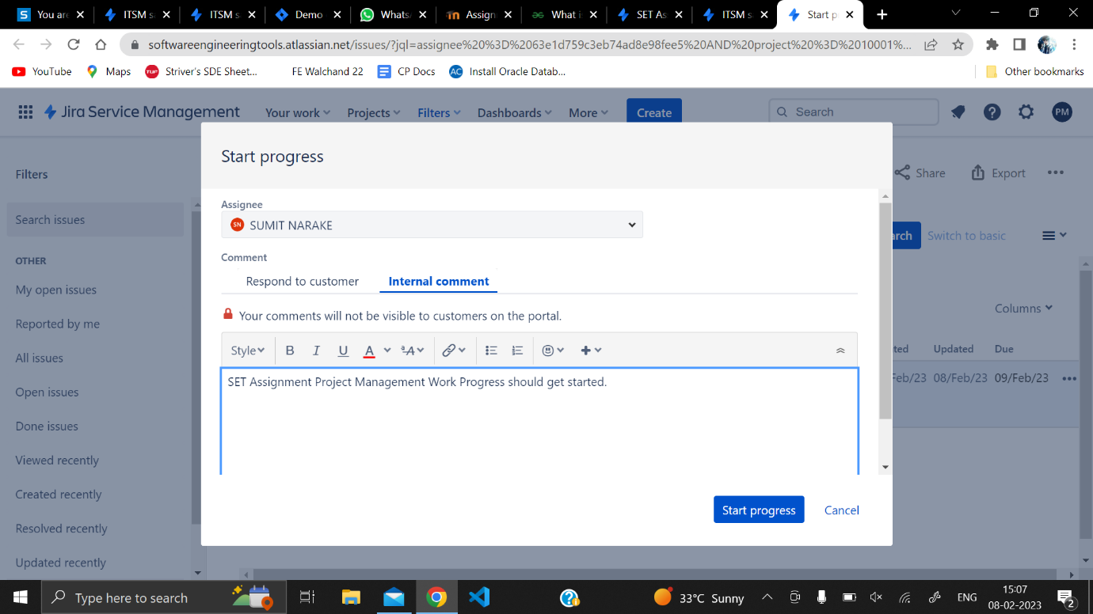

2.Creating Epic in JIRA Software Backlog

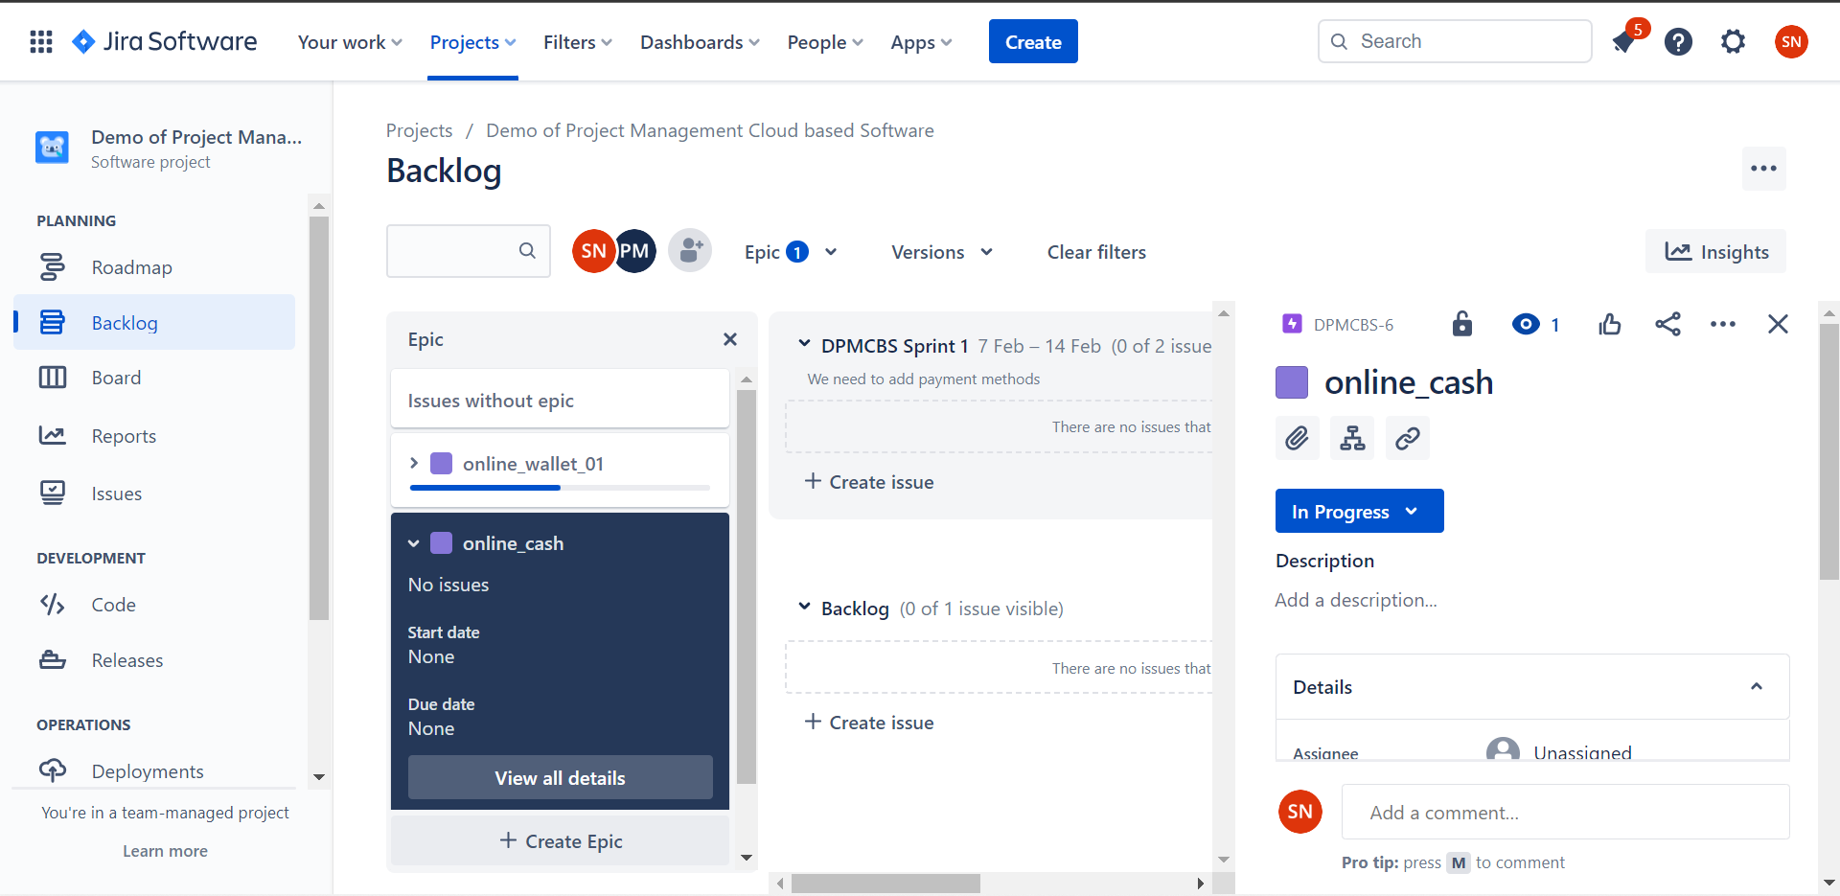

3. Creating stories in epic

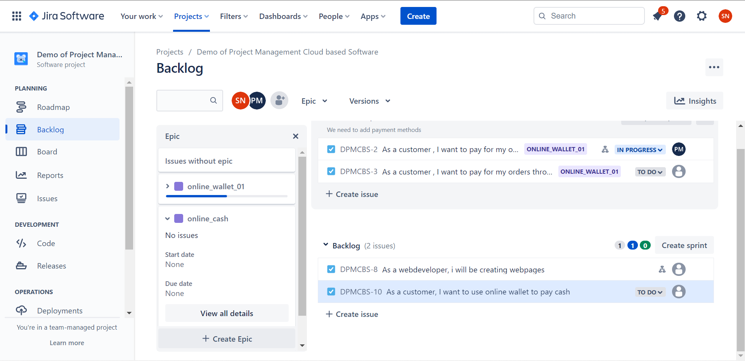

4. Creating subtasks in stories

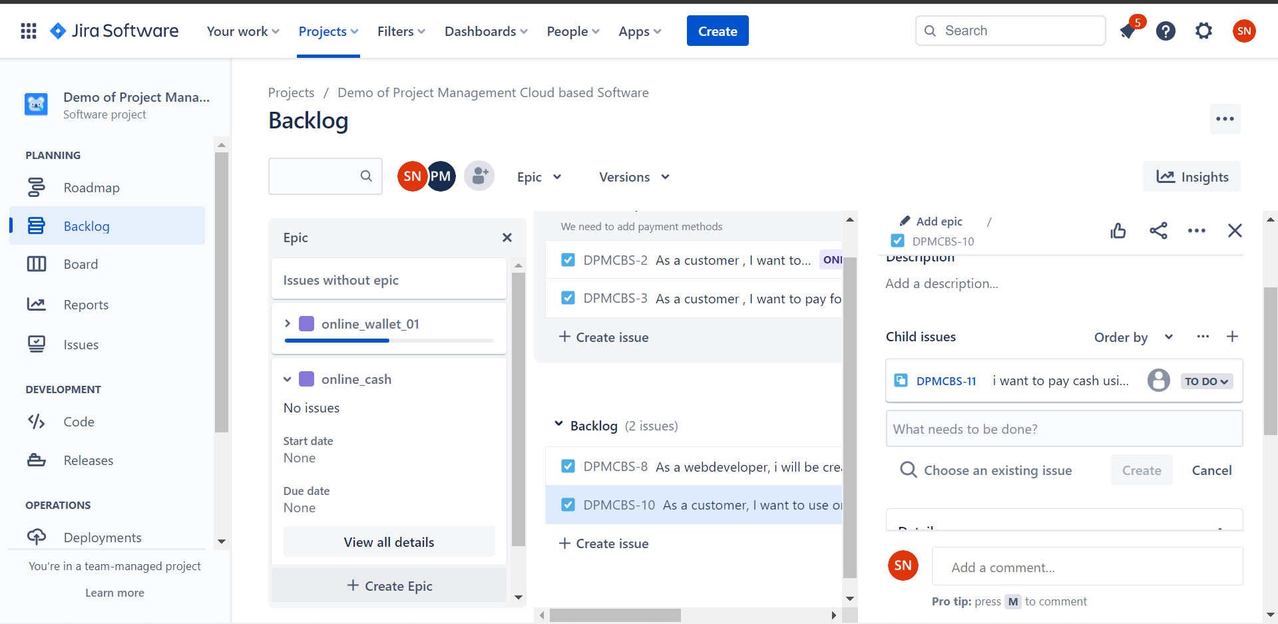

5. Task Board in JIRA Software

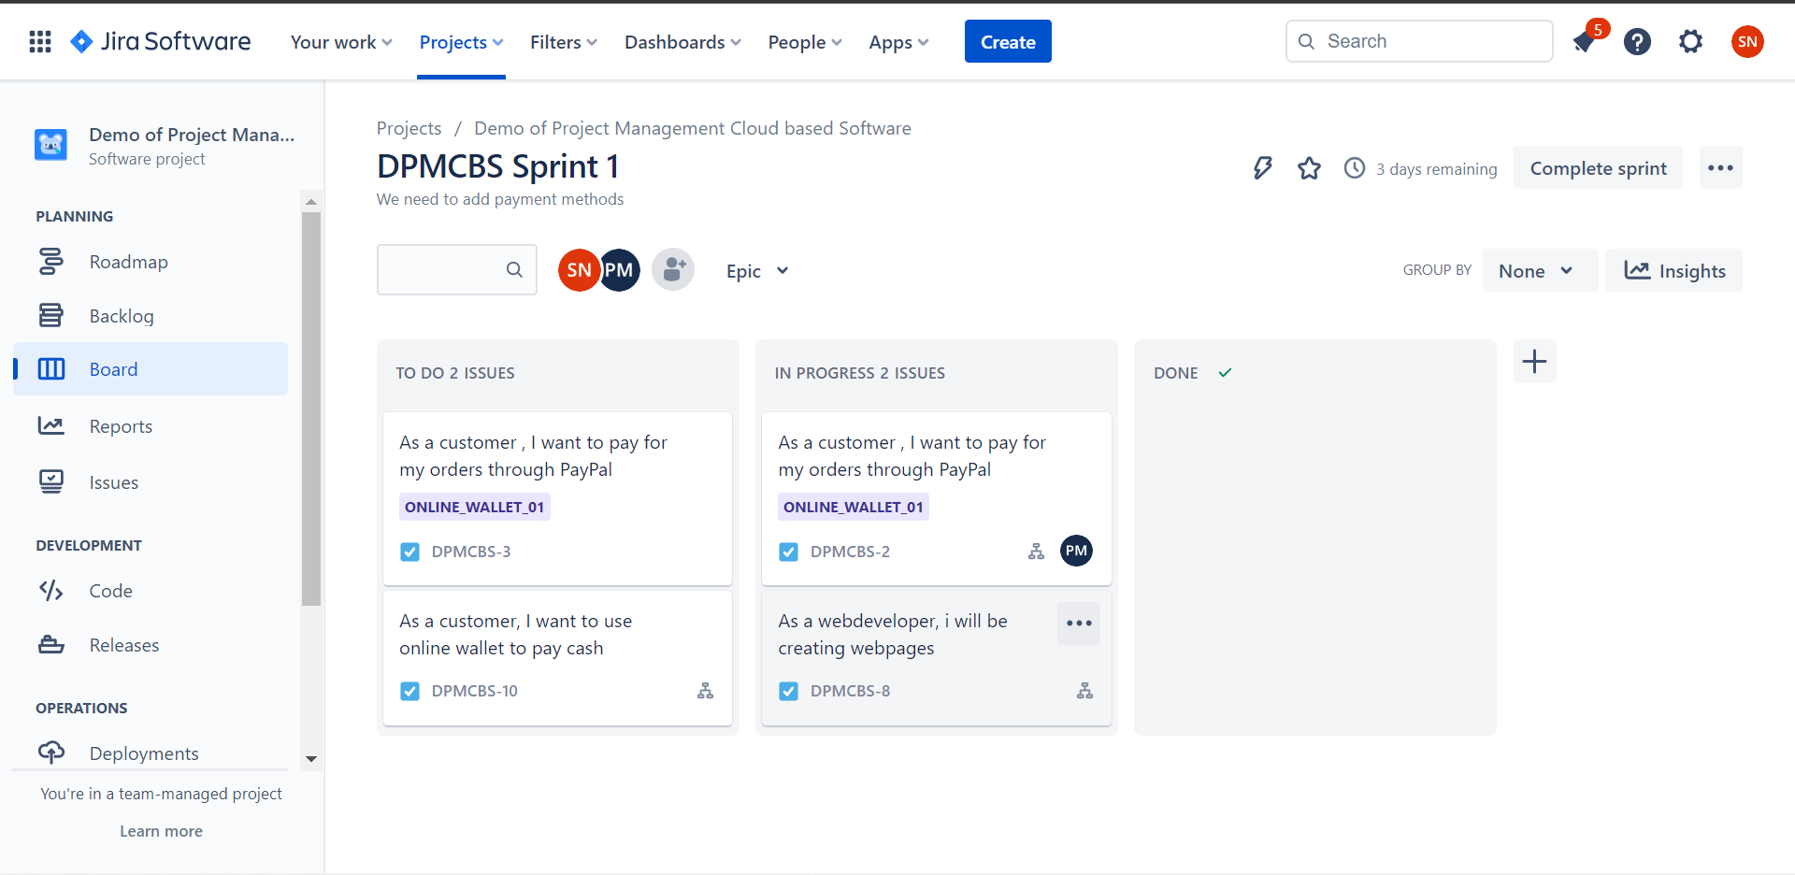

6. Roadmap in JIRA Software

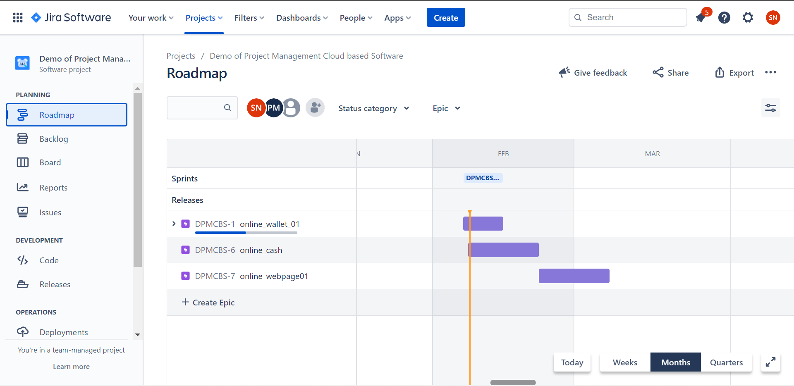

7. All issues, subtasks, stories in JIRA Software

